The WATCH Chronicle  

WATCH is a court monitoring and judicial policy non-profit located in Minneapolis, Minnesota. WATCH works to make the justice system more responsive to crimes of violence against women and children, focusing on greater safety for victims of violence and greater accountability for violent offenders.
July 2017 Volume 3, Issue 6


A message from the Executive Director:
As we enter the middle of summer and my fourth month as Executive Director at WATCH, I wanted to focus our July newsletter on the topic of victim advocacy. Our first article focuses on an individual working to end domestic violence in our community. Vernona Boswell is the director of the Hennepin County Domestic Abuse Service Center. This is more than a profile; it is an opportunity for the WATCH community to learn about the personal and professional experience of someone who is engaged in the daily work of our court system. I hope you value not only the information we share in this profile but our overall approach to the newsletter.
WATCH can only achieve its goal of transforming the justice system to be more responsive to crimes of violence against women and children, and offer greater accountability for violent offenders, with the assistance of generous donations from our supporters. Please remember WATCH as you plan your charitable giving for the remainder of 2017.
DONATE here: https://watchmn.org/support-watch/
Nicholas Paul Cichowicz, J.D. MA
Vernona Boswell: ‘Passionate about empowering women’

By Mark Wollemann
Whenever Vernona Boswell has witnessed violence against women, even as a child, she has spoken up. Now, many decades later, she continues that important work as the director of the Hennepin County Domestic Abuse Service Center.
“I grew up in domestic violence,” Boswell said. “I saw my sisters, my mom … so I always thought, ‘no, that will never be me.’ … I wouldn’t stand for men hitting women.”
Boswell, who was born in Memphis and spent part of her youth traveling between her hometown and the Twin Cities, has been advocating for victims of domestic violence her entire adult life (not to mention her childhood).

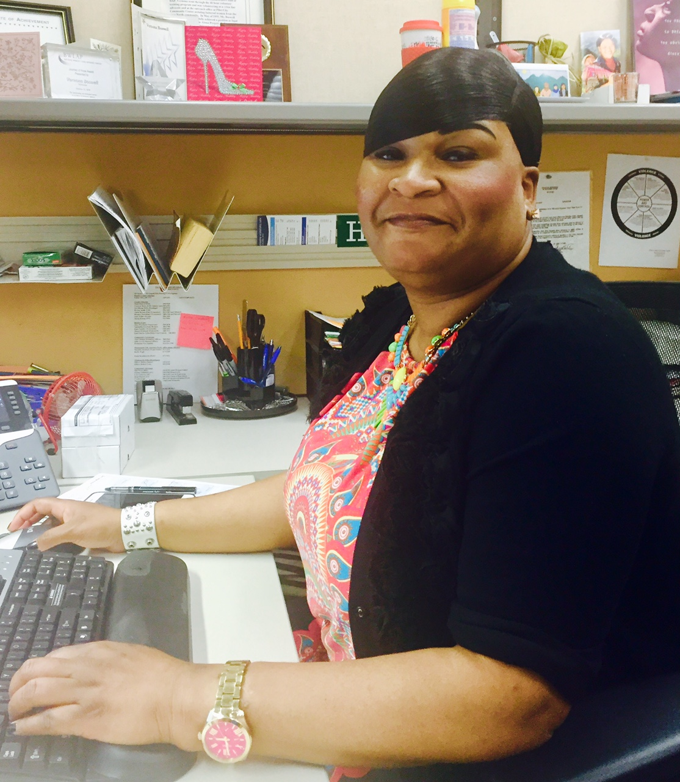

Vernona Boswell, director of the Hennepin County Domestic Abuse Service Center

Inside:
In The News 3-4

Court Monitoring Update 5-6
From The Blog 6
Volunteers Needed 6

She spent her senior year of high school in Minnesota and graduated from Minneapolis South. She was a teen mother of a young son and decided to stay in the Twin Cities because of the opportunities it presented.
Boswell attended Minnesota Community & Technical College and earned an associate’s degree in computer operations. Armed with her degree, she set out confidently to find a job.
“I was a young, black girl with a child and I remember I wanted to get off welfare,” she said. “I was proud I had graduated on time with my class from high school, and I thought I’d be able to get a job.”
Vernona applied to be a receptionist at the Domestic Abuse Project in South Minneapolis. Things didn’t fall into place as she had hoped. After applying and interviewing, she was convinced she’d get the job. But that did not happen – immediately.
“I was bummed out, but I kind of kept it moving,” Boswell said. “A week later, the officer manager (at DAP) called and asked if I was still interested in the job. The person they hired didn’t work out. … I said, absolutely! She said the job is yours. … And that’s where it all began.”
Soon after starting work as a receptionist, Boswell learned of an opportunity to volunteer as an advocate for victims of domestic violence. “I was hungry for knowledge and information,” she said.
Boswell worked full-time as a receptionist during the week and as a volunteer advocate on the weekends. After a year, a paid advocate position opened up. She applied and was hired, “and that’s really how my career took off.”
After spending five years working for the Domestic Abuse Project in a variety of roles, she entered Augsburg College to pursue a bachelor’s degree in social work. She knew how she was going to put that degree to work.
“I began working in the County Attorney’s office 19 years ago, and still to this day I’m very passionate about empowering women,” Boswell said.
She said there have been positive changes for women and children who are victims of domestic violence, but “the violence has not changed.”
What has changed, Boswell said, is the respect she feels advocates receive from others working in this field. “Judges, probation officers, clerks, deputies … they look to advocates for our expertise in the field,” she said. “The respect (for advocates) has changed enormously, which is really, really good.”
And the work they do has reach: In 2016, DASC provided direct advocacy services to nearly 4,000 victims and advocated in court for almost 2,000.
Those courtroom experiences are enhanced when DASC advocates show up and see a WATCH monitor there as well. Boswell said she’s been grateful over
“Judges, probation officers, clerks, deputies … they look to advocates for our expertise in the field. The respect (for advocates) has changed enormously, and that’s really, really good.”
– Vernona Boswell
***
DOMESTIC ABUSE RESOURCES
Hennepin County Domestic Abuse Service Center
Phone: 612-348-5073
24-Hour Metro Crisis Line: 612-379-6363
24-Hour Domestic Violence Line for Counseling and Shelter: 1-866-223-1111
Address:
A-Level A0650 Lower Level, Hennepin County Government Center
300 South Sixth Street
Minneapolis, MN 55487
Hours: 8 a.m.-4:30 p.m.

the years for WATCH’s volunteers “and that red clipboard.” She said she believes WATCH’s presence in the courtroom leads to a more just outcome in difficult cases.
“We completely relied on WATCH to be there just because we felt its presence … would be beneficial to the victim,” she said.
In recent years, DASC has grown to include a variety of culturally specific services, sharing space at the center’s Hennepin County Government Center with representatives of Hmong, Somali, Native American, Latino and LBGTQ organizations. In 2016, those advocates helped nearly 1,300 victims from their respective communities.
Maintaining physical, mental and emotional energy in her demanding work hasn’t been easy, but Boswell, the mother of a soon-to-be 30-year-old daughter and 22-year-old son, says she works out regularly and is constantly “re-energized by my amazing staff here.”
“I have a really good group of advocates … and they’re the ones really doing the work,” she said. “I had my time (as an advocate). Now I try to help give the advocates the tools and guidance and my knowledge of 23 years doing this work. I think that’s what energizes me and keeps me coming back for another day.”
∞
 In the news
Police chief arrested in sex sting
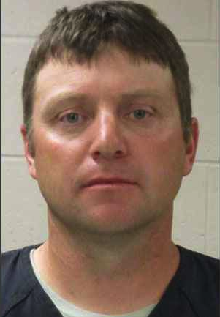
The police chief of Walnut Grove, Minn., and two other men were charged with felony attempting to hire a minor for sex in Redwood County District Court on June 12.
The arrests came through a regional drug and human trafficking task force from Washington County dubbed “Operation Guardian Angel.”
Michael R. Zeug, 45, was suspended indefinitely later that day by the Walnut Grove City Council. Zueg was the only full-time member of the Walnut Grove Police Department and was paid a salary of $44,200.
The other two men caught up in the sting operation, Scott G. Berglund, 41, of Montevideo, and Javier B. Turrubiartes, 40, of Renville, were also charged.
Read the Star Tribune story about the arrest and charges here.
(Services, continued) The DASC has received a grant from the Office of Justice Programs (OJP) to provide culturally specific services to African-American victims.

***

A sampling of other organizations that work with the Domestic Abuse Service Center:

Domestic Abuse Project
Phone: 612-874-7063 (x232)
Casa de Esperanza Minnesota
A national organization with a chapter in St. Paul for victims in the Hispanic community.
24-hour Minnesota crisis line: 651-772-1611
Phone: 651-646-5553
Asian Women United
Programs and expertise focus on Asian women and girls.
24-hour crisis line: 612-724-8823
Phone: 612-724-0756
Division of Indian Works
Family violence prevention for adult American Indian mothers, fathers and expectant parents.
Phone: 612-722-8722
Voice of East African Women, Inc.
Services for East African and Muslim women.
Phone: 612-236-4093
OutFront Minnesota
Anti-Violence Program
A broad-based effort to end violence and harassment against and within LGBTQA-identified communities in Minnesota.
Anti-Violence Program crisis line: 612-822-0127

In the news (cont.)
Minn. state rep. breaks up domestic assault

In addition to working through a grueling budgeting process, a Minnesota state representative helped stop an assault in downtown St. Paul last month that turned out to be a domestic assault with threats of more violence to come.
Rep. John Lesch was driving to his law office in downtown St. Paul in early June when he saw a man repeatedly hitting a woman. The man had grabbed her purse, sending its contents flying. Lesch parked his car and ran over to help, and the man, who turned out to be the woman’s boyfriend, ran away. She was upset and showed signs of visible scrapes and bruises, so Lesch led her into a restaurant so they could call 911. But soon, her boyfriend’s brother came inside the restaurant and threatened Lesch and the woman. The boyfriend, Shii-Hiem Collins, 21, from St. Paul, was later arrested and charged with felony domestic assault by strangulation.
Lesch, 44, who represents St. Paul, serves in the National Guard. He posted his story to his Facebook page. In his Facebook post, Lesch included a link to donate to Women’s Advocates, which calls itself the nation’s first shelter for women and children escaping domestic abuse.
You can read the Star Tribune’s story here.

MNDOT is raising awareness about
human trafficking with rest area posters
In June, the Minnesota Department of Transportation (MNDOT) began installing posters in 41 rest areas across the state to educate the traveling public about human trafficking and to encourage them to report suspicious activity. The posters include guidelines on how to recognize signs of human trafficking and potential victims and a toll-free hotline to report any suspicious activity.
“According to the Federal Bureau of Investigation, the Twin Cities is one of the 13 U.S. cities with a particularly high rate of child prostitution, and Minnesota has the third highest number of human trafficking cases in the nation,” said MNDOT Commissioner Charlie Zelle.
You can read more about the program here.

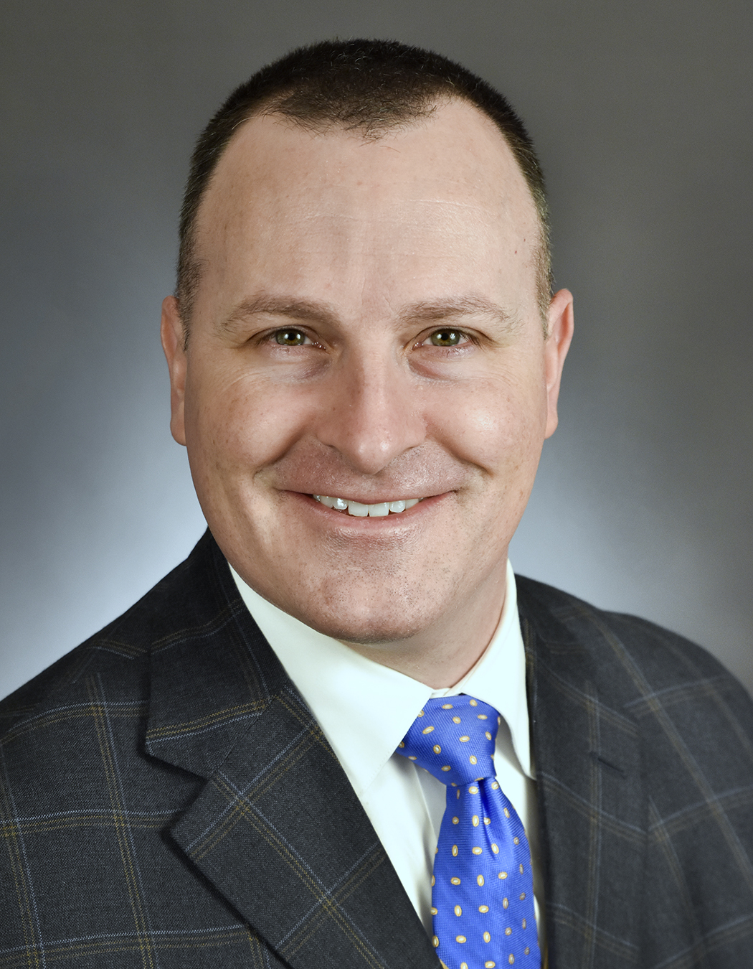
Rep. John Lesch

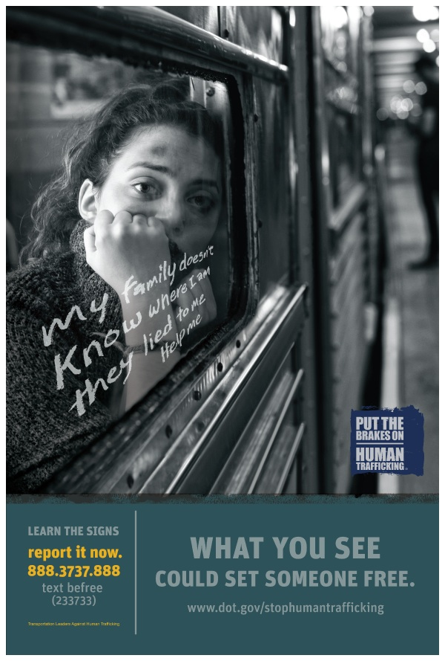
Court monitoring update
Ramsey County: WATCH report to assess cases of abuse against women, children
After 25 years of monitoring Hennepin Courts, WATCH’s board of directors and staff determined that there was a need and that we had the capacity as an organization to begin monitoring courtrooms in Ramsey County, specifically criminal hearings at the Law Enforcement Center and the Ramsey County Courthouse. WATCH began sending volunteers into courtrooms at the start of the sex trafficking project, Sex Trafficking Cases: Where a Public Movement Meets the Criminal Justice System, in 2014 to monitor cases of sex trafficking only. In January of 2016, WATCH made the decision to monitor all cases of violence against women and children. Today, WATCH has volunteers in these courtrooms on a regular basis.
WATCH will be releasing a report based on initial findings in Ramsey County in early fall 2017. In this report WATCH will focus on five aspects of judicial demeanor including: (1) Respect and Courtroom Decorum, (2) Efficiency, (3) Impartiality, (4) Accountability, and (5) Communication. Other notable topics in this report include attorney behavior, the need for childcare services within the court system, and the importance of addressing domestic violence gun restrictions on the record.
Between Jan. 1, 2016, and May 31, 2017, WATCH volunteers observed 647 hearings on cases related to domestic assault, criminal sexual conduct, child abuse and sex trafficking in Ramsey County.
Throughout this time, the volunteers observed 585 defendants; some defendants had multiple hearings throughout the project timeline and were charged with offenses related to domestic assault, sexual assault, child abuse or sex trafficking. Volunteers monitored 17 Ramsey County judges.
The purpose of this report is to also lay the groundwork for future research in Ramsey County and to provide recommendations on ways to better handle cases of violence against women and children.


Watch will be releasing a report based on initial findings in Ramsey County in early fall 2017. … Between Jan. 1, 2017, and May 31, 2017, WATCH volunteers observed 647 hearings on cases related to domestic assault, criminal sexual conduct, child abuse and sex trafficking in Ramsey County.

Court monitoring update (cont.)
Hennepin County: Sharing observations from our monitors in the courtroom
WATCH would like to continue a long tradition of sharing the great work being done by those involved in the court system in Hennepin County. Our court monitors regularly share positive comments about their experiences in the courtroom. This month, we’d like to share a set of court monitor comments that highlight victim advocacy:
“The prosecutor did an excellent job advocating for victim safety. Frequently argued for DANCO and read sections from victim statement and police report.”
“Judge repeatedly emphasized victim safety.”
“By far, she is the most victim- and public safety-centered judge I have seen. She carefully gives thought to how rulings could impact victims and voices those concerns. In terms of bonds and the conditions for release, she holds the defendant accountable in a way that factors in the nature of the case.”
“Made sure victim understood what it meant to lift the protection order. Asked both the victim and her boyfriend multiple questions about her safety and their relationship.”
________________________________________________________________
From the blog: Intern experiences
As an intern, I am exposed to both the experiences within the courtroom, as our volunteers are, and the data review process. I have experienced a wide variety of cases within the courtroom. One such experience that I recall is when I was asked to sit in on a domestic assault case in which the defendant was the father of the victim. The victim was a minor with a very shy and timid demeanor and was shaking on the stand while testifying. The judge residing on this case was very gracious to the victim and even took her aside for a moment to say, "Breathe, you can be heard here."
Later that day, I was asked to process the court monitoring forms and couldn't help but see the immense quantity of other domestic assault cases that WATCH has been reporting on. These cases often times go unheard or unnoticed due to the personal nature of these crimes, but WATCH stands behind their mission to make the public more knowledgeable about what is happening within their community courts.
You can read more blog posts here.
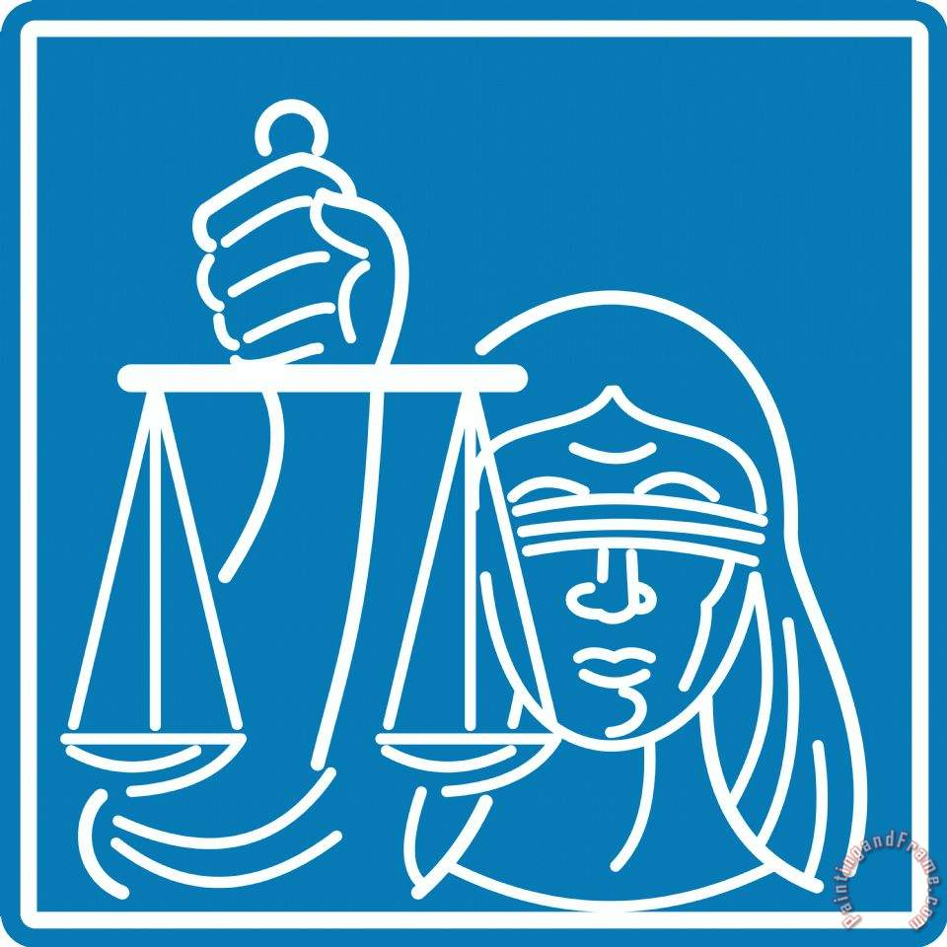

Volunteers and interns needed
WATCH is a court monitoring and research organization based in Hennepin County. It is focused on improving the justice system’s response to crimes of domestic violence, sexual assault, child abuse and neglect and human trafficking so victimized women and children can rebuild their lives. Its secondary aim is to create a more informed public.
Position description: Volunteers visit courtrooms in Hennepin County (Minneapolis), Ramsey County (St. Paul) and Washington County (Stillwater) to observe and take notes on cases pertaining to violence against women and children. Volunteers fill out WATCH forms that are provided, and turn them into the WATCH office after each shift.
WATCH volunteer shifts are Monday through Friday, either 8:45 a.m.-12:45 p.m., or 12:45-4 p.m.
Online training sessions are required. Applicants must fill out a volunteer application, interview with the Program Manager and pass a background check.
How to apply: Please contact the Program Manager Ellen Sackrison at watchvolunteer@watchmn.org.
There is a link to our application in the volunteer section on our website http://www.watchmn.org/. Please complete the form and e-mail it to the above e-mail or send via mail.

