The WATCH Chronicle  

WATCH is a court monitoring and judicial policy non-profit located in Minneapolis, Minnesota. WATCH works to make the justice system more responsive to crimes of violence against women and children, focusing on greater safety for victims of violence and greater accountability for violent offenders.

2017 Volume 3, Issue 5



Outgoing Executive Director Amy Kern, left, shared a moment of appreciation and mutual admiration for Gold WATCH award honoree Marilyn Carlson Nelson earlier this month.

Inside
In the News 3
Judges Training 4
Monitoring Bulletin 5

WATCH honors Carlson Nelson
with its Gold WATCH award
By Pam Schmid
WATCH celebrated its accomplishments and look ahead to a new era of leadership at its annual spring celebration in Minneapolis on May 2nd.
WATCH honored Marilyn Carlson Nelson, former chair and chief executive officer of Carlson, the global travel company, with the Gold WATCH award for her pioneering leadership in combating human trafficking worldwide.
“Your unwavering personal commitment has created an awareness of sex trafficking issues both at home and abroad and inspired civic leaders and elected officials to take action,” Amy Kern, WATCH’s outgoing executive director, told Carlson Nelson in bestowing the award. “By standing up for the young and vulnerable, you have literally saved lives all over the world.”
Kern’s remarks to about 150 attendees—including judges, volunteers, past Gold WATCH recipients and supporters at The Woman’s Club of Minneapolis—marked her final public appearance as WATCH’s leader after three years at the helm. Nick Cichowicz was hired in March to replace Kern, who is leaving to start a legal consulting business. “I am very confident in his abilities to lead this organization,” she said of her successor.
In the coming year, Kern said, WATCH will:
- Track and monitor nearly 10,000 hearings in Hennepin County and 7,000 more in Ramsey County.
- Make specific recommendations for improving policies and procedures in Ramsey County, especially around the handling of domestic abuse cases involving no-contact orders.

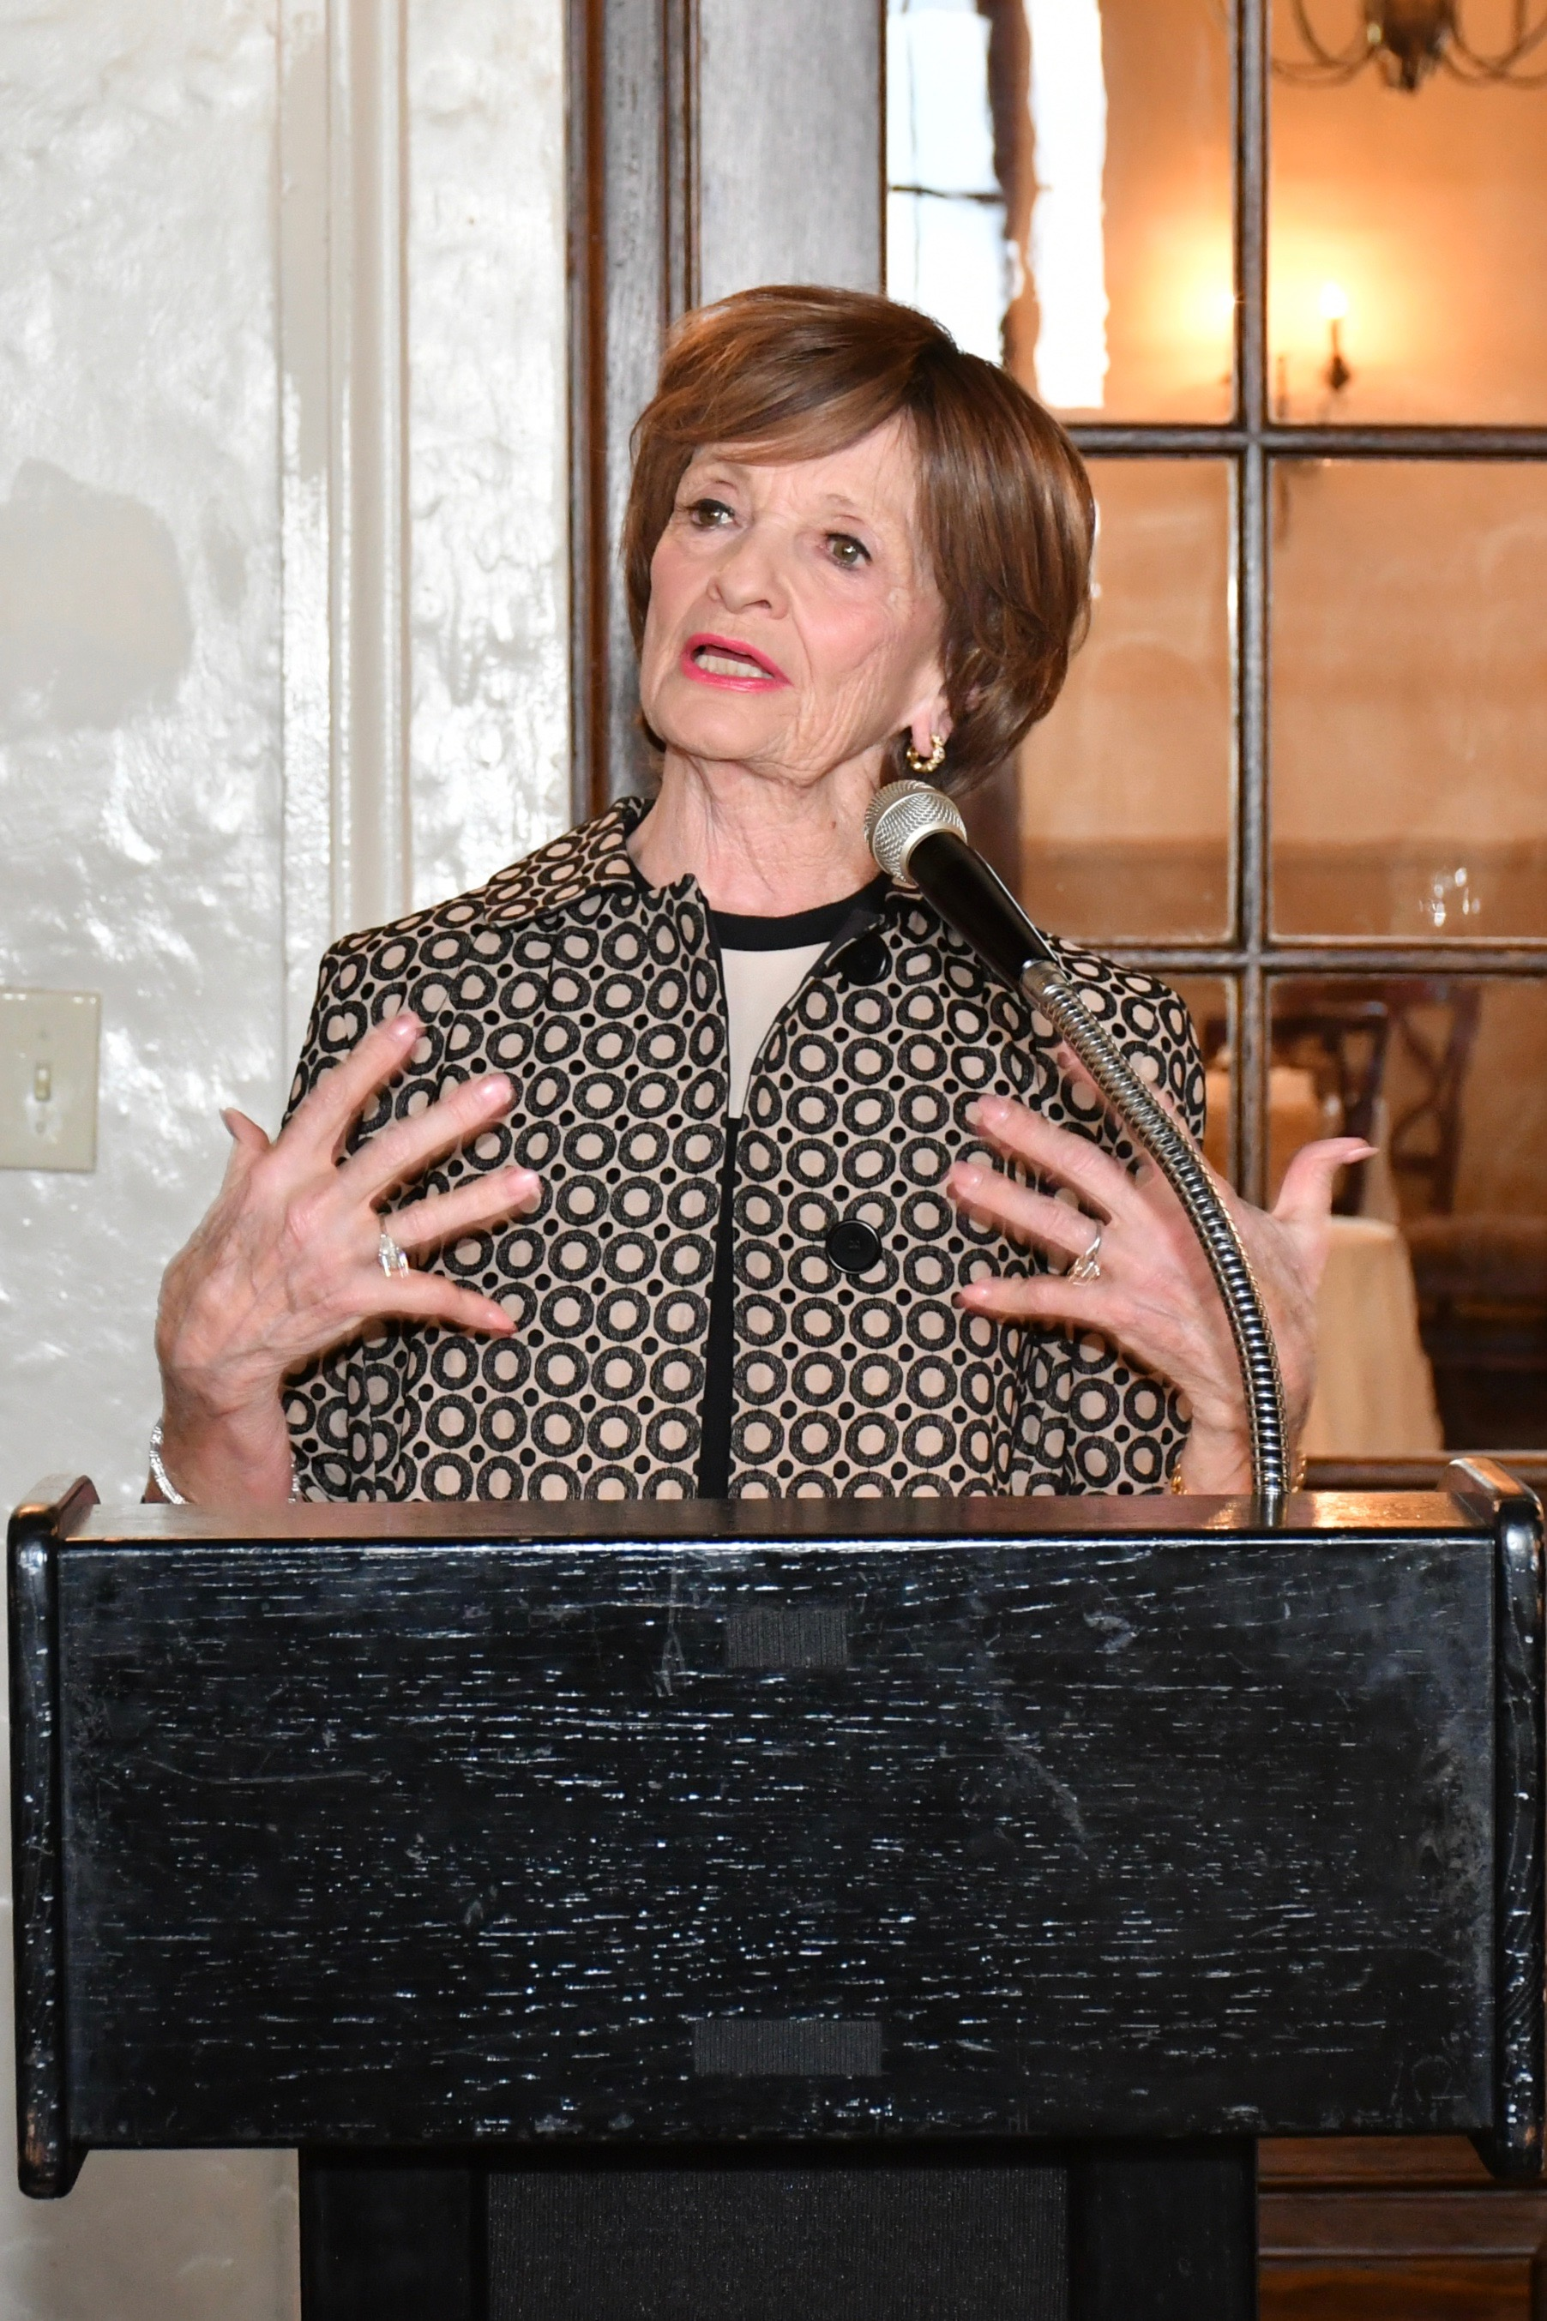

“[But] it was a problem we now knew about. … Could we fix it? Could we possibly win? We didn’t know, but we really had to try.”
Marilyn Carlson Nelson on leading the travel industry into the fight against child prostitution.

- Work with Hennepin County to develop training on prosecutions of sex trafficking cases in the wake of WATCH’s groundbreaking sex trafficking report released last December.
Kern also said that WATCH is turning its focus to “the demand side of the sex trafficking equation,” tracking all sex buyer cases in Hennepin and Ramsey counties. The effort comes as sex trafficking receives added attention with the Super Bowl coming to Minneapolis in February 2018.
Initial data from the 62 cases that are now closed indicates that sex buyers are “very unlikely” to receive prison time as part of their sentence, Kern said. While many variables affect prison sentences, she added, “we still have to ask ourselves whether these sentences are sufficient to deter individuals from buying Minnesota women and girls.”
Carlson Nelson received the GOLD Watch award, Kern said, because of the way she used her “extraordinary leadership skills and her business platform” to take on the issue of human trafficking worldwide. Under her watch, Carlson in 2004 became the first travel company based in North America to sign the industry’s International Code of Conduct to end child prostitution, child pornography and trafficking of children for sex.
In her remarks, Carlson Nelson admitted signing onto the Code of Conduct with some trepidation. When the U.S. State Department identified the hospitality industry as an “unwitting facilitator” of the practice of child prostitution in asking her to sign it, she had not even been aware that child prostitution existed. “I didn’t even know if I could say the words out loud,” she recalled. “[But] it was a problem we now knew about. … Could we fix it? Could we possibly win? We didn’t know, but we really had to try.”
Carlson remained the only U.S-based global organization to sign the Code until 2011. In recent years, companies such as Hilton, Wyndham and Delta have also signed on.
Signing the Code was only the beginning — for both Carlson Nelson and her company. Doing so made no difference, she said, if “no one was there to answer our call for help. … It didn’t matter that [we made the call] if we didn’t train law enforcement to intervene. It didn’t matter if the victim was rescued if there was no appropriate place to shelter that child. And it certainly didn’t matter if the perpetrator was apprehended if the laws and court system were weak in meting out convictions and sentences.
“The entire community must come into play” to help those in need, she said. “That’s why I’m proudly standing here tonight, to take your hands.
“… The fight is real, the momentum is real, and together we will continue to make a difference.”

 IN THE NEWS

Two from Minnetonka charged
with sex trafficking and other crimes
A Minnetonka pair suspected of running a national underage sex trafficking ring from their home there were charged with several felonies in mid-May.
Washington County prosecutors allege that Ricky Arlen Turner, 28, and Brittany Marie Harenza, 25, used the dating link on Backpage.com to advertise girls and women for prostitution and used social media to lure females into the business. Turner was charged with five felony counts including sex trafficking and racketeering. Harenza was charged with racketeering and engaging in business to conceal criminal proceeds.
Police said they have found evidence that the pair may have operated in 14 states. Woodbury police detectives, who led the investigation, spent months obtaining search warrants and then combing through Internet, phone, travel and business records to build their case. Harenza, a sex worker whom police called Turner’s trusted female business partner, helped recruit new girls.
Read the Star Tribune report here.
___________________________________________________
Pohlads to help fill funding gap
The Pohlad Family Foundation on May 22 said it will give $1 million in emergency grants to non-profits, including those that serve as domestic violence shelters, because of funding cuts those shelters absorbed due to the $6 million fundraising shortfall at the Greater Twin Cities United Way. The foundation in late May invited 40 nonprofit organizations that were facing cuts of 40 percent or more in United Way funding to apply for grants that would help them cover some of the shortfall for the coming fiscal year.
In April, the United Way announced it would eliminate its Safety From Family Violence support, among other program cuts. The Pohlad Foundation anticipates awarding as many as 20 grants of up to $100,000 each, according to its executive director, Susan Bass Roberts. Applications are by invitation only and due June 9, and grant notifications will be made the week of July 1.
Read the Star Tribune story here.
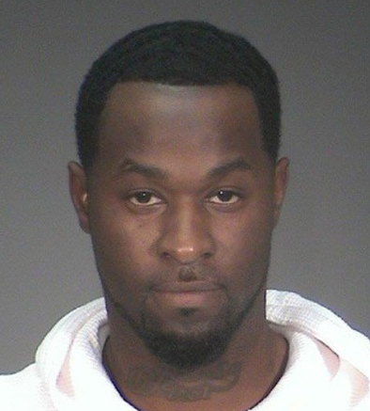
Ricky Arlen Turner
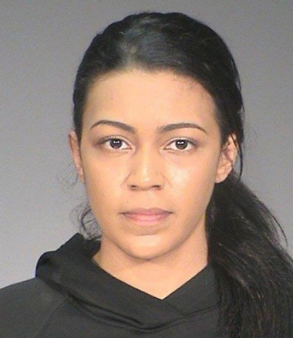
Brittany Marie Harenza

State Coalition for Battered Women
recognizes two violent deaths in May
To honor the lives of Tawnja Wallace and Lacey Kuschel, Minnesota’s seventh and eighth known victims of domestic violence in 2017, more than 500 agencies, universities, businesses and individuals from across the state will raise the Live Free Without Violence flag, a public awareness campaign spearheaded by the Minnesota Coalition for Battered Women.
“Following Mother’s Day, we are devastated to raise the flag for two women … and we are thinking of their children, who have been left motherless,” said Liz Richards, executive director of the group.
Eddie Frazier, 49, has been charged with second-degree murder in the death of his girlfriend, Wallace, who was 48, in Crookston on or around May 3. Frazier was arrested on May 4 in Bloomington and was later charged after a six-hour manhunt, during which law enforcement went door to door in search of him.
In February, Tyler Slagerman, 32, was charged with second-degree unintentional manslaughter in the shooting death of Kuschel, his girlfriend. She was 35. Slagerman was also charged with one count of child endangerment.
More on the Wallace-Frazier case here.
More on the Slagerman-Kuschel case here.
You can see the MCBW press release here.


JUDGES’ TRAINING
Sharing our mission with incoming judges As part of our mission, WATCH provides new judges in Hennepin County with training and education that offers insights about our history, mission and role in the courtroom. Our most recent training session took place in late May.
This interaction allows WATCH staff to interact with judges and judicial staff while explaining WATCH’s mission and vision. We share updated WATCH data and explain and seek input for monitor forms, which are used by volunteers in the courtroom.
These are great forums for us to communicate with judges and provide a detailed history and review of past judges’ surveys conducted by WATCH.
Nick Cichowicz, WATCH executive director

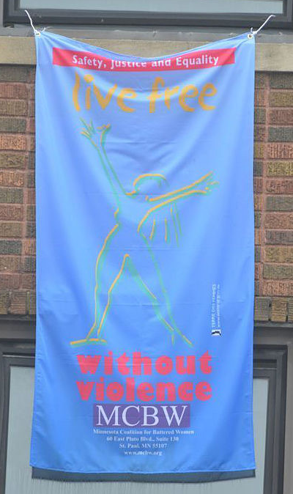
“Following Mother’s Day, we are devastated to raise the flag for two women … and we are thinking of their children.”
Liz Richards of the Minnesota Coalition for Battered Women.

COURT MONITORING BULLETIN:
Washington County more similar
than dissimilar to more urban counties
Kevin Ness, a recent graduate of the University of Minnesota, has been a WATCH intern since last July and has been monitoring cases most recently in Washington County. WATCH was asked by a systems player to monitor sex trafficking cases in Washington County, so Kevin stepped in. Here is his report:
***
For the past couple of months, I have gone every Thursday to monitor proceedings at the Washington County Government Center and Courthouse complex in Stillwater. During that time, I have monitored eight different judges, all of whom have seemed to possess excellent qualities of judicial leadership, balancing the interests of the victims, defendants, and the state. In this sense, Washington County is no different than Hennepin or Ramsey counties – all three have great jurists who fairly interpret and enforce the law.
Where Washington County differs from the other two counties is in the population, court personnel, and overall court proceedings. In the seven-county metropolitan area, Washington County is the third smallest, with just over 251,000 people. Correspondingly, this means that the overall caseload is much smaller than either Hennepin or Ramsey.
Washington County does an excellent job of keeping defendants informed of the court proceedings. Unlike in Hennepin or Ramsey, Washington County will list the defendant’s name on a screen both inside and outside the court in the order they will be called. The order is usually established by who checks in with the clerk first, but varies depending on priority of cases.
That kind of order is helpful to both court monitors and defendants. Having a video screen listing defendants’ names keeps attorneys informed and better prepared for their cases. Almost all of the defense attorneys are public defenders, so this helps give them additional time to prepare.
My time in Washington Count was very positive. Seemingly everyone involved was respectful of the court process and was considerate of others. The prosecutors were knowledgeable and the judges seemed to consider the interests of the public and the severity of the crime in sentencing.
I am proud to say that I have spread WATCH’s court-monitoring mission to a new county, and I hope our presence there continues.
• Kevin Ness is a 2017 graduate of the University of Minnesota. He majored in urban studies and geography. He plans to attend law school in the fall of 2018.


“I am proud to say that I have spread WATCH’s court-monitoring mission to a new county.”
Kevin Ness, WATCH monitor
WATCH blog
May 3, 2017: Today the judge made a direct comment to the defendant that sex trafficking and prostitution of minors is a crime driven by demand. She added that johns, like the defendant, who solicit sex from minors don’t realize that they are directly causing many women’s lives to be permanently scarred from sexual exploitation. I was impressed that the judge confronted the defendant with such a harsh but truthful statement about the implications of his crime. To read more of the WATCH blogs, go here.

